Modelled and guided writing is a used across school.

‘Aim Higher’ stickers provide an extra level of challenge.

Writing is cross curricular and often has a geographical, historical or scientific theme.

Our Learning Journeys give writing a purpose and an audience.

Writing is often experiential and linked to real life situations.

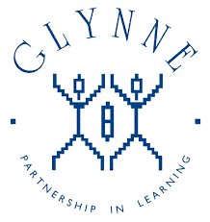

Subject Leaders share their knowledge to lead effectively.

Editing and redrafting are a fundamental part of the writing process.

Year 2 and Year 6 staff attend LA moderation and training.

Writing is frequently moderated within phases and with local schools.

Writing is often linked to a key text.

‘Supersonic Phonic Friends’ handwriting scheme introduced.

Children experience a wide range of genres linked to

Learning Journeys.

Intervention groups identified through marking and data.

Marking, both written and verbal, identifies next steps.

Teachers challenge all writers and have ambitious expectations.

High expectations of the application of phonics and GPS in writing.

Writing Assessment books track each child’s writing from EYFS to Year 6.

Staff attend CPD and disseminate ideas to colleagues.

Classroom and corridor displays reflect writing opportunities.

Year 6: 75% of children reached the expected standard (above national)

GPS is delivered discretely as well as being linked to Learning Journeys.

Staff are passionate about writing.

Glynne Primary School

What does

Writing look like?

Year 2: 68% of children reached the expected standard (above national)